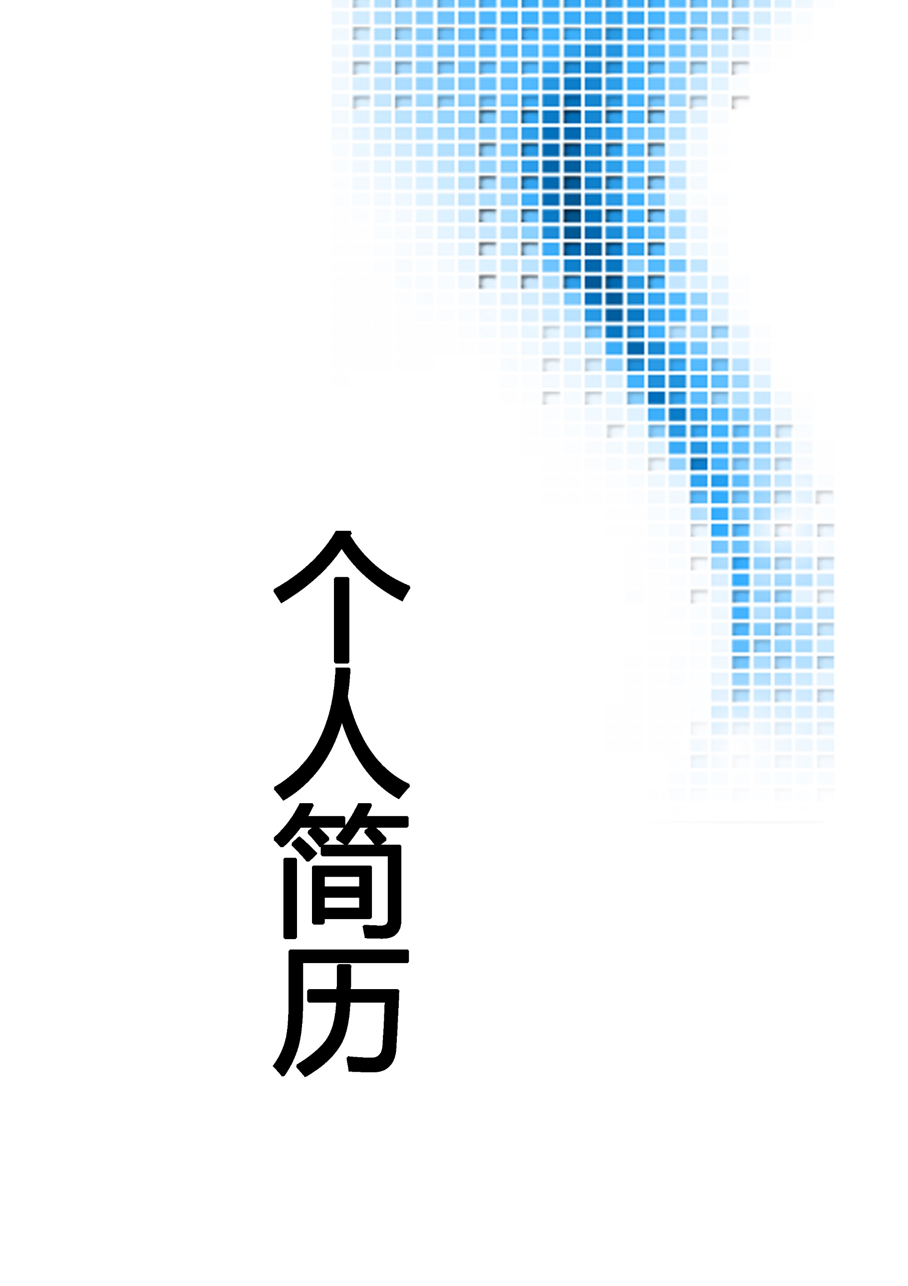

飞小扬

13800138000

224438838@qq.com